**Islanninkoirat – Islandshundarna ry Finland**

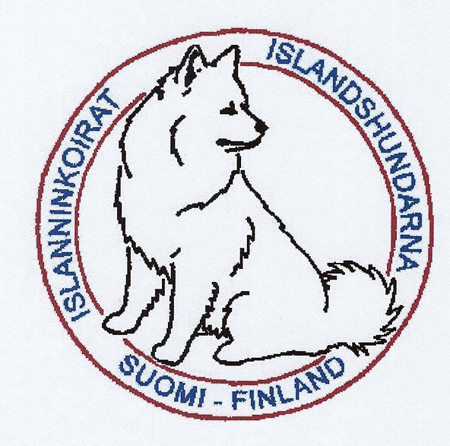

**Annual report for the year**

**2020**

**The 26 th International seminar for**

**the Icelandic Sheepdog**

**Oslo 30th -31th October 2021**

**Board members**

Chairman: Riika Kivirinta   
 Jokiontie 4 as 7  
 19700 Sysmä  
 [puheenjohtaja@islanninkoirat.fi](mailto:puheenjohtaja@islanninkoirat.fi)

Vice Chairman: Jonna Savukari

Treasurer: Ritva Kylävuori  
 [rahastonhoitaja@islanninkoirat.fi](mailto:rahastonhoitaja@islanninkoirat.fi)

Secretary: Heidi Hautala  
 [sihteeri@islanninkoirat.fi](mailto:sihteeri@islanninkoirat.fi)

Committee member: Sanna Rasimus  
 Riikka Tyni  
 Henni Särkiniemi  
 Marika Rajala

Substitute: Iitamari Laamanen  
 Anna Vainionpää

Tanja Karttunen

**Commitees  
  
Breeding committee:**  
Chairman: Anne Vaskio  
 Kirkkomäentie 110   
 12310 Ryttylä

[jalostus.islanninkoirat@gmail.com](mailto:jalostus.islanninkoirat@gmail.com)

**Committee members:** Heidi Hautala

Anni Hirvonen  
 Jonna Savukari  
 Riika Kivirinta  
 Kirsi Honkala

**Herding committee:**  
Chairman: Sanna Rasimus  
 [paimennus@islanninkoirat.fi](mailto:paimennus@islanninkoirat.fi)

**Committee members:** Leena Lehti

Riitta Lumiluoto  
 Marika Rajala  
 Kirsi Asikainen

**Magazine:** Riikka Tyni  
 [hundurlehti@islanninkoirat.fi](mailto:hundurlehti@islanninkoirat.fi)

**Club members**

|  |  |  |  |  |  |
| --- | --- | --- | --- | --- | --- |
|  | **2020**  31th December | **2019**  31th December | **2018**  31th December | **2017**  31th December | **2016**  31th December |
| **Members** | **296** | **287** | **282** | **296** | **250** |

**Summary**

Year 2020 was a little bit slower and more uneventfull than years before because of covid-19. But in the summer time dogsports started again and we had nice amount of actvity after that. In agility there was 127 starts and in rally obedience 80. Two dogs earned a title of finish rally obedience champion, Aitiorannan Dalla Dunros and Una v. Rogici. Icelandic sheepdog people were also active in herding and obedience. Nosework became an official event in finish kennelclub and from the start there has been icelandic sheepdogs competing in this too.

As a club we organized a speciality show through internet because it would have been too big event to have with covid regulations. We had 109 dogs participating with their pictures. BOB was Morgundis Isafold and our judge was Erika Häkkinen. Otherwise it was very quiet year with one exception and that was how much demand there was for puppies. Icelandic sheepdog demand in Finland clearly grew last year.

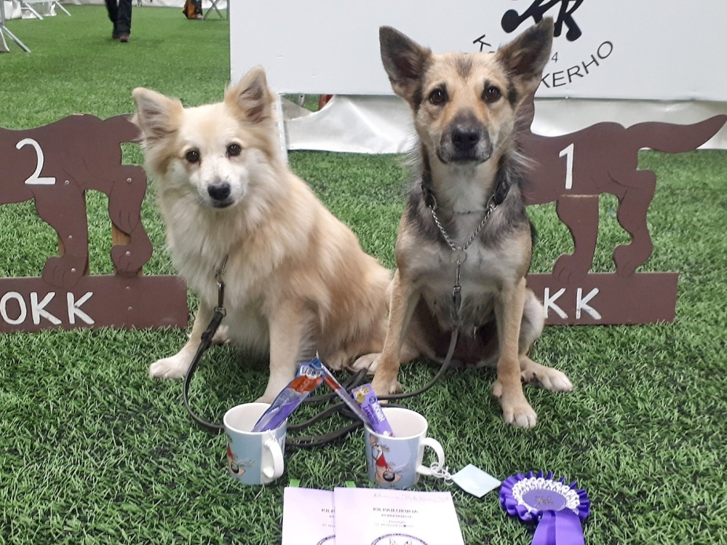

New Rally-Obedience champions: Aitiorannan Dalla Dunros & Una van Rogici (picture: Heidi Slöggs)

**Litters**

|  |  |  |  |  |  |
| --- | --- | --- | --- | --- | --- |
|  | **2020** | **2019** | **2018** | **2017** | **2016** |
| **Litters** | 20 | 16 | 11 | 10 | 12 |
| **Puppies registrated** | 87 | 71 | 51 | 40 | 57 |
| **Average size of litters** | 4,4 | 4,5 | 4,6 | 4,0 | 4,8 |
| **Average inbreeding %** | 0,98% | 0,61% | 0,69% | 0,66% | 0,59% |

**Imports**

|  |  |  |  |  |  |
| --- | --- | --- | --- | --- | --- |
|  | **2020** | **2019** | **2018** | **2017** | **2016** |
| Denmark |  | 1 | 1 | 1 | 1 |
| Germany |  |  | 1 |  |  |
| Iceland |  | 1 | 1 | 1 |  |
| Nederland | 3 | 2 | 3 |  |  |
| Norway | 3 |  | 1 |  |  |
| Sweden | 1 | 2 |  | 1 | 1 |
| USA |  |  |  | 1 | 1 |
| Poland |  |  | 1 |  |  |

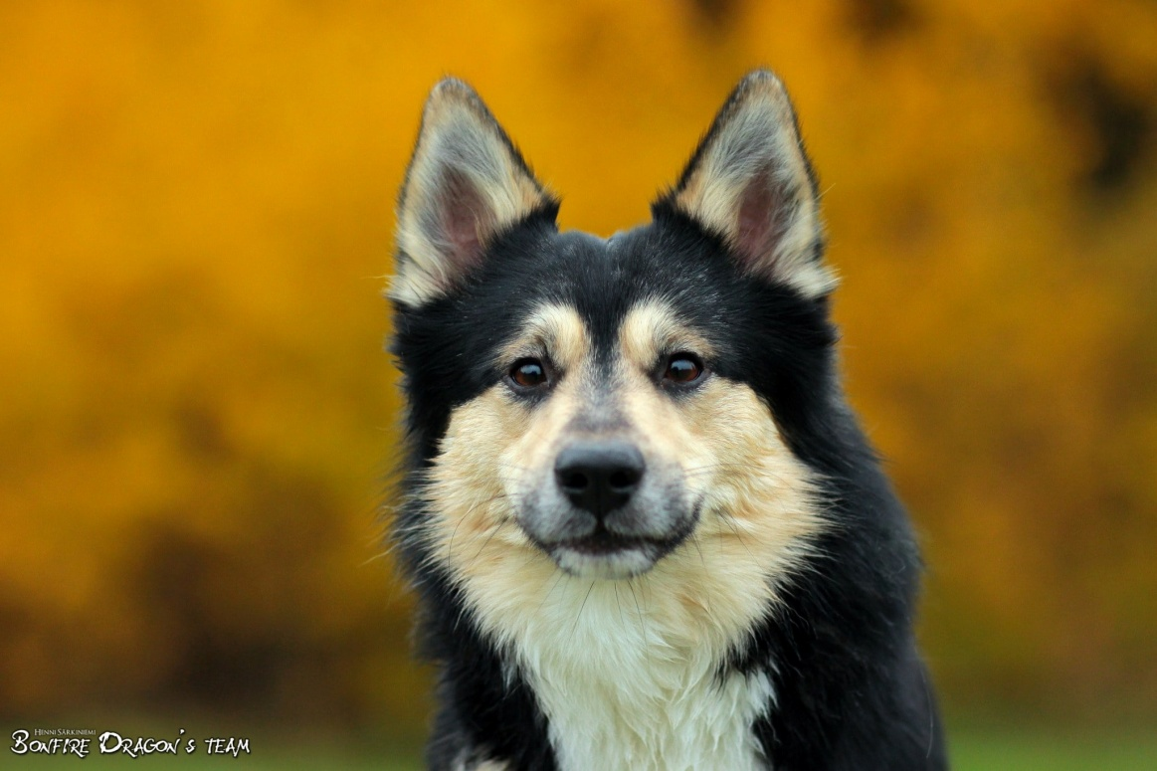Hjörvar Ylurson af Láglendinu, picture Henni Särkiniemi **Imports 2020:**

NO39016/20 Fjölskyld Ljósvaki Kátson (Ástvinur Kátur Silfurgeisli x Myst van Rogici)  
NHSB3043813 Úti van Rogici (Flórus fra Isafold x Mc Eremons Gou Miska)  
NHSB2999688 Odda van Rogici (Connor van Rogici x Isdalur's Disa)  
NO3518/20 Losnabakken's T-E Stjarni Einsson (Sunnusteins Einir x Losnabakken's N-A Táta)  
NO3517/20 Losnabakken's T-E Stilir Einsson (Sunnusteins Einir x Losnabakken's N-A Táta)  
NHSB3165889 Hjörvar Ylurson af Láglendinu (Ylur Preguson frá Fuglatorgi x Aitiorannan Brana Mýsla)

SE55837/2019 Joneshill's Beisla Ljufsdottir (Tellusdream Ljúfur x Ellringslätts Bessa)

**Stud dogs**

Who have reached – or are close – to the “ISIC breeding limit”   
We don't have any dogs who are close these limits, so here are stud dogs which are close our limits or over it.

|  |  |  |  |  |  |
| --- | --- | --- | --- | --- | --- |
| **Males** | | | | | |
| **Reg nr.** | **Name of the dog** | **Year of birth** | **No. of Litters** | **No. of Puppies** | **No of grandchildren** |
| S56940/94  FIN19628/95 | Gydjans Mundilfari | 1994 | 4 | **24** | 26 |
| IS16196/11  FI59085/11 | Stefsstells Kambur Harald | 2011 | 5 | **22** | 31 |
| FIN17748/04 | Vuoreksen Zimba | 2004 | 4 | **21** | 25 |
| IS10181/06  FIN32687/07 | Kersins Bjartur II | 2007 | 3 | 13 | **50** |
| FIN41213/02 | Tunturiketun Vaskur | 2002 | 3 | 12 | **47** |

|  |  |  |  |  |  |
| --- | --- | --- | --- | --- | --- |
| **Females** | | | | | |
| **Reg nr.** | **Name of the dog** | **Year of birth** | **No. of Litters** | **No. of Puppies** | **No of grandchildren** |
| S52756/96  FIN23371/97 | Glims Embla | 1996 | 4 | **25** | 26 |
| SF23442/94 | Tunturiketun Asta-Sollilja | 1994 | 2 | **23** | 33 |
| FI54457/09 | Aitiorannan Jodis Josefina | 2009 | 3 | 18 | 31 |
| FSSDN19286606  ER28536/08 | Runestone Mocha Latte | 2007 | 2 | 15 | 24 |
| FIN26108/95 | Tuulenpuuskan Drifa | 1995 | 3 | 15 | 36 |

Here are dogs whose are closest our breed limits or over them. Now we have a rule to the registration, that dog who is under 5 years old can get only 9 puppies (of course whole litter will register even it goes over that) and after that dog can get 18 puppies (and again whole litter will register even it goes over that).  
Idea of this was fighting against a matador breeding and using very young dogs too much.   
Our registration numbers of a dogs have been only 40-50 puppies / year many years and because it our national limits have to be much lower than ISIC international limits. Now numbers are growing up, but we will see in couple years is that only corona uprising or real chance.

**Hip Dysplasia** (**HD)**

|  |  |  |  |  |  |
| --- | --- | --- | --- | --- | --- |
| **Total number of x-rayed dogs** | **2020** | **2019** | **2018** | **2017** | **2016** |
| **A** | 31 (57%) | 14 (32%) | 12 (32%) | 15 (37%) | 15 (38%) |
| **B** | 16 (30%) | 12 (27%) | 17 (46%) | 16 (39%) | 17 (44%) |
| **A+B** | **47 (87%)** | **26 (59%)** | **29 (78%)** | **31 (76%)** | **32 (82%)** |
| **C** | 5 (9%) | 14 (32%) | 5 (14%) | 8 (20%) | 4 (10%) |
| **D** | 2 (4%) | 2 (5%) | 3 (8%) | 2 (5%) | 3 (8%) |
| **E** | - | 2 (5%) | - | - | - |
| **C+D+E** | **18 (13%)** | **18 (42%)** | **8 (22%)** | **10 (25%)** | **7 (18%)** |
| **In total** | **54** | **44** | **37** | **41** | **39** |

**Elbow dysplasia (ED)**

|  |  |  |  |  |  |
| --- | --- | --- | --- | --- | --- |
| **Total number of x-rayed dogs** | **2020** | **2019** | **2018** | **2017** | **2016** |
| **Level 0** | 28 (97%) | 34 (100%) | 26 (100%) | 22 (100%) | 27 (96%) |
| **Level 1** | 1 (3%) | - | - | - | 1 (4%) |
| **Level 2** | - | - | - | - | - |
| **Level 3** | - | - | - | - | - |
| **In total** | **29** | **34** | **26** | **22** | **28** |

**Patella luxation:**

|  |  |  |  |  |  |
| --- | --- | --- | --- | --- | --- |
| **Total number of examined dogs** | **2020** | **2019** | **2018** | **2017** | **2016** |
| **Level 0** | 65 (96%) | 67 (97%) | 54 (93%) | 48 (96%) | 52 (96%) |
| **Level 1** | 2 (3%) | 2 (3%) | 3 (5%) | 2 (4%) | 2 (4%) |
| **Level 2** | - | - | 1 (2%) | - | - |
| **Level 3** | - | - | - | - | - |
| **Operate** | 1 (1%) | - | - | - | - |
| **In total** | **69** | **69** | **58** | **50** | **54** |

**Operate dog:**Gelgja's Bára (Gelgja's Skirnir x Punapihlajan Amma) Her left knee is 0 and right have been operate after patella luxation.

The Finnish Kennel club has a rule that the knee result is valid only for two years if the dog is under three years old, when the knees are checked. This means that many dogs have been – and will be - checked knees two times. 2012 is the first year for this rule, so the figure also includes double-checked dogs. There was even now any tool to pick only one result from each dog.

**Eye examinations**

|  |  |  |  |  |  |
| --- | --- | --- | --- | --- | --- |
| **Total number of examined dogs** | **2020** | **2019** | **2018** | **2017** | **2016** |
| **Unaffected signifies (free)** | 57 | 72 | 63 | 52 | 48 |
| **Hereditary**  **Cataract** | - | - | 1 | 1 | 1 |
| **Cornea Distrophe** | - | - | - | - | - |
| **Distichiatis** | 1 | 2 | 2 | 2 | 1 |
| **Others**  **(see below)** | 3 | 6 | 3 | 3 | 3 |
| **In total** | **61** | **78** | **68** | **57** | **53** |

**Other hereditary eye diseases:**

2016 Others: 2 x PRA suspicion these are same dogs than year 2012, 1 x cataract suspicion,  
2017 Others: 1 x PRA, 1 x PRA suspicion, 1 x Atresia of lacrimal punctum  
2018 Others: 1 x PHTVL/PHPV, 1 x RD, 1 x Atresia of lacrimal punctum (this dog has also distichiatis)  
2019 Others: Ectopic cilia x 2, Iris hypoplasia x 1, PHTVL/PHPV grade 1 x 1, PHTVL/PHPV grade 2 x 1, PPM 1 x 1  
2020 Others: PHTVL/PHPV grade 1 x 1, 1 x Atresia of lacrimal punctum, 1 x RD

**Health, optional testing**

|  |  |  |  |  |  |
| --- | --- | --- | --- | --- | --- |
|  | **2020** | **2019** | **2018** | **2017** | **2016** |
| **BAER**  **(Hearing diseases)** | - | - | - | - | - |
| **Heart diseases** | - | 1 | 1 | - | - |
| **Kidney diseases** | - | - | - | - | 1 |
| **Epilepsy** | - | - | - | - | - |
| **Malocclusion** | 1 | 1 | - | - | - |

In year 2019 one litter (two puppies) BAER tested because they were over white - but both have normal hearing.  
  
Heart diseases:  
2019 one murmur grade 2: Rekikelin Eldlilja Sofisdóttir (Brytarspetzens Eros x Rekikelin Snjóhvit)  
2018 on murmur grade 1: Rastihaukun Netla (Punapihlajan Nammi x Rastihaukun Dimma)  
Kidney diseases:  
2016 Rastihaukun Unnar Wikkesson (Nuppusen Ungur Viktor x Punapihlajan Gnepja)  
Malocclusion:   
2019 Smahildur's Elvis Elfur (Ginfaxi's Dagfinnur x Smahildur's Doppa Dynfara)  
2020 Tunturiketun Reifur (Gladur Tryggvi x Gelgja's Galdra)

**Mentality descriptions**

|  |  |  |  |  |  |
| --- | --- | --- | --- | --- | --- |
|  | **2020** | **2019** | **2018** | **2017** | **2016** |
| **Descripted dogs** | 16/1 | 20/1 | 26/3 | 17/5 | 26/- |
| **In total** | **17** | **21** | **29** | **22** | **26** |

The first number is the “old version” Finnish character tested dogs and second is for MH- tested dogs. MH-test doesn’t work very well in Finland. Hopefully we will find a solution to this problem in the future and get more dogs to MH.

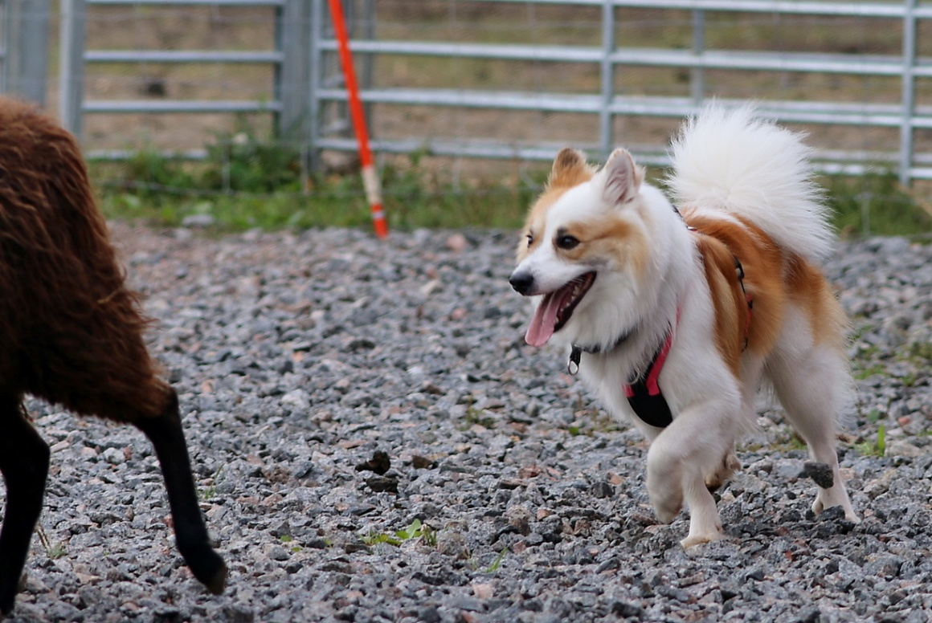

Skelmir (Sunnusteins Islandsljómi x Meyjamist) picture Anne Vaskio

**Working abilities (herding) descriptions**

|  |  |  |  |  |  |
| --- | --- | --- | --- | --- | --- |
|  | **2020** | **2019** | **2018** | **2017** | **2016** |
| **Descripted dogs**  **unofficial** | - | - | - | - | - |
| **Ability test for sheepdog – traditional style** | 14 | 11 | 16 | 7 | 2 |
| **Herding working test – traditional style** | 11 | 11 | 6 | 2 | 5 |
| **Herding trial – traditional style:  1st class** | 20 | 20 | 4 | 7 | - |
| **2nd class** | 7 | 9 | 6 | 1 | - |
| **3rd class** | 13 | 7 | 3 | - | - |
| **In total** | **65** | **58** | **29** | **17** | **7** |

Results are from official traditional style test, Finnish kennelklub / FCI test to the other breeds than Bordercollies. Herding is very rising hobby in Finland. Again we have also one dog (Kári fra Klettakoti) in traditional style herding Finnish championsip.

**Shows**

|  |  |  |  |  |  |
| --- | --- | --- | --- | --- | --- |
|  | **2020** | **2019** | **2018** | **2017** | **2016** |
| **Number of shows** | - | 1 | 1 | 1 | 1 |
| **Number of dogs** | - | 88 | 49 | 63 | 86 |
| **In total (dogs)** | **-** | **88** | **49** | **63** | **86** |

Year 2020 we have only dog show in a web. People send pictures and real show judge criticized them.

*Morgundis Isafold, BOB of our internet speciality show.*

**Litters**

|  |  |  |  |  |  |  |  |  |  |  |  |  |  |  |  |
| --- | --- | --- | --- | --- | --- | --- | --- | --- | --- | --- | --- | --- | --- | --- | --- |
|  | **2006** | **2007** | **2008** | **2008** | **2010** | **2011** | **2012** | **2013** | **2014** | **2015** | **2016** | **2017** | **2018** | **2019** | **2020** |
| **Litters** | 8 | 10 | 15 | 10 | 11 | 11 | 12 | 19 | 14 | 10 | 12 | 10 | 11 | 16 | 20 |
| **Puppies** | 35 | 45 | 71 | 45 | 62 | 43 | 58 | 87 | 64 | 40 | 57 | 40 | 51 | 71 | 87 |
| **Average size of litters** | 4,4 | 4,5 | 4,7 | 4,5 | 5,6 | 3,9 | 4,6 | 4,6 | 4,6 | 4,0 | 4,8 | 4,0 | 4,6 | 4,5 | 4,4 |
| **Average inbreeding %** | 1,02% | 0,29% | 0,86% | 1,50% | 0,56% | 1,16% | 1,23% | 0,72% | 0,49% | 0,78 | 0,59% | 0,66% | 0,69% | 0,61% | 0,98% |

**Imports**

|  |  |  |  |  |  |  |  |  |  |  |  |  |  |  |  |
| --- | --- | --- | --- | --- | --- | --- | --- | --- | --- | --- | --- | --- | --- | --- | --- |
|  | **2006** | **2007** | **2008** | **2008** | **2010** | **2011** | **2012** | **2013** | **2014** | **2015** | **2016** | **2017** | **2018** | **2019** | **2020** |
| Denmark |  | 3 |  | 1 |  | 1 |  |  |  |  | 1 | 1 | 1 | 1 |  |
| Estonia | 4 |  |  |  |  |  |  |  |  |  |  |  |  |  |  |
| Germany |  |  | 1 | 1 |  | 1 | 2 |  |  | 1 |  |  | 1 |  |  |
| Iceland | 2 | 2 |  | 2 | 1 |  | 1 | 1 | 1 | 1 |  | 1 | 1 | 1 |  |
| Nederland | 1 | 1 | 1 | 1 |  |  |  | 1 |  |  |  |  | 3 | 2 | 3 |
| Norway |  |  | 1 |  |  | 1 |  |  |  |  |  |  |  |  | 3 |
| Sweden |  | 1 | 1 | 2 | 2 | 1 |  |  |  | 2 | 1 | 1 |  | 2 | 1 |
| Switzerland |  | 2 |  |  |  |  |  |  |  |  |  |  |  |  |  |
| USA | 2 | 1 | 3 |  |  |  |  |  |  |  | 1 | 1 |  |  |  |
| Poland |  |  |  |  |  |  |  |  |  |  |  |  | 1 |  |  |

**Hip Dysplasia** (**HD)**

|  |  |  |  |  |  |  |  |  |  |  |  |  |  |  |  |
| --- | --- | --- | --- | --- | --- | --- | --- | --- | --- | --- | --- | --- | --- | --- | --- |
| **Total number of x-rayed dogs** | **2006** | **2007** | **2008** | **2008** | **2010** | **2011** | **2012** | **2013** | **2014** | **2015** | **2016** | **2017** | **2018** | **2019** | **2020** |
| **A** | 13 | 16 | 16 | 15 | 22 | 25 | 24 | 17 | 15 | 22 | 15 | 15 | 12 | 14 | 31 |
| **B** | 9 | 9 | 4 | 8 | 11 | 11 | 12 | 6 | 22 | 17 | 17 | 16 | 17 | 12 | 16 |
| **A+B** | **22** | **25** | **20** | **23** | **33** | **36** | **36** | **23** | **37** | **39** | **32** | **31** | **29** | **26** | **47** |
| **C** | 8 | 8 | 9 | 14 | 5 | 4 | 9 | 7 | 8 | 11 | 4 | 8 | 5 | 14 | 5 |
| **D** | 2 | 2 | 6 | 6 | 4 | 4 | 1 | 5 | 4 | 5 | 3 | 2 | 3 | 2 | 2 |
| **E** | - | - | - | - | - | 1 | - | - | - | - | - | - | - | 2 | - |
| **C+D+E** | **10** | **10** | **15** | **20** | **9** | **9** | **10** | **12** | **12** | **16** | **7** | **10** | **8** | **18** | **7** |
| **In total** | **32** | **35** | **35** | **43** | **42** | **45** | **46** | **35** | **49** | **55** | **39** | **41** | **37** | **44** | **54** |

**Elbow dysplasia (ED)**

|  |  |  |  |  |  |  |  |  |  |  |  |  |  |  |
| --- | --- | --- | --- | --- | --- | --- | --- | --- | --- | --- | --- | --- | --- | --- |
| **Total number of x-rayed dogs** | **2007** | **2008** | **2008** | **2010** | **2011** | **2012** | **2013** | **2014** | **2015** | **2016** | **2017** | **2018** | **2019** | **2020** |
| **Level 0** | 31 | 22 | 31 | 24 | 27 | 26 | 18 | 33 | 34 | 27 | 22 | 26 | 34 | 28 |
| **Level 1** | - | - | - | - | 1 | - | - | - | 2 | 1 | - | - | - | 1 |
| **Level 2** | - | - | - | - | - | - | - | - | - | - | - | - | - | - |
| **Level 3** | - | - | - | - | - | - | - | - | - | - | - | - | - | - |
| **In total** | **31** | **22** | **31** | **24** | **28** | **26** | **18** | **33** | **36** | **28** | **22** | **26** | **34** | **29** |

**Patella luxation:**

|  |  |  |  |  |  |  |  |  |  |  |  |  |  |  |
| --- | --- | --- | --- | --- | --- | --- | --- | --- | --- | --- | --- | --- | --- | --- |
| **Total number of x-rayed dogs** | **2007** | **2008** | **2008** | **2010** | **2011** | **2012** | **2013** | **2014** | **2015** | **2016** | **2017** | **2018** | **2019** | **2020** |
| **Level 0** | 38 | 19 | 30 | 33 | 41 | 60 | 49 | 34 | 53 | 52 | 48 | 54 | 67 | 65 |
| **Level 1** | 2 | - | 3 | - | 1 | 3 | 2 | 5 | 1 | 2 | 2 | 3 | 2 | 2 |
| **Level 2** | - | 1 | 1 | - | - | - | - | 1 | 3 | - | - | 1 | - | - |
| **Level 3** | - | - | - | - | - | - | - | - | - | - | - | - | - | - |
| **operate** | - | - | - | - | - | - | - | - | - | - | - | - | - | 1 |
| **In total** | **40** | **20** | **34** | **33** | **42** | **63** | **51** | **40** | **57** | **54** | **50** | **58** | **69** | **68** |

**Eye examinations**

|  |  |  |  |  |  |  |  |  |  |  |  |  |  |  |
| --- | --- | --- | --- | --- | --- | --- | --- | --- | --- | --- | --- | --- | --- | --- |
| **Total number of x-rayed dogs** | **2007** | **2008** | **2008** | **2010** | **2011** | **2012** | **2013** | **2014** | **2015** | **2016** | **2017** | **2018** | **2019** | **2020** |
| **Unaffected signifies (free)** | 65 | 38 | 62 | 54 | 80 | 55 | 59 | 47 | 73 | 48 | 52 | 63 | 72 | 57 |
| **Hereditary**  **Cataract** | - | 1* | 1 | - | 1 | 1 | - | 1 | - | 1 | 1 | 1 | - | - |
| **Cornea Distrophe** | - | - | - | - | - | - | 2 | - | - | - | - | - | - | - |
| **Distichiatis** | - | 2 | 1 | - | - | 1 | 2 | - | 3 | 1 | 2 | 2 | 2 | 1 |
| **Others** | 4 | 1 | 3 | - | - | 3 | 1 | - | - | 3 | 3 | 3 | 6 | 3 |
| **In total** | **69** | **42** | **67** | **54** | **81** | **60** | **64** | **48** | **40** | **53** | **57** | **68** | **78** | **61** |